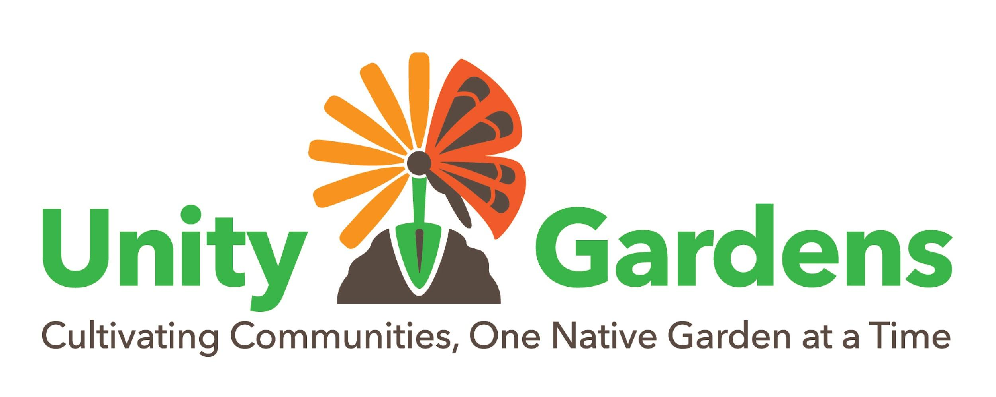
Spring 2022 Grant Application

Spring 2022 Application Deadline
Requests for the Spring 2022 Grant Cycle must be submitted no later than midnight on March 1, 2022. Please refer to the Grant Guidelines before completing the application. Early submission is appreciated and encouraged to allow adequate time to review your application and ensure that all required information has been included.
Instructions
To apply for a grant, please provide the information requested on the following application form. Applicants are required to prepare and submit several attachments in support of their application.
These attachments include a 1) Project Description, 2) Photos of the existing site 3) Sketch of proposed design, 4) Maintenance Plan, and 5) a Proposed Budget. Applications will be considered incomplete until the attachments are received.
There are two ways to submit. 1) Use the online application and upload each of the required attachments when prompted (preferred). 2) Complete this form and email it with the required attachments. If you use the online form, we recommend you review all requirements and prepare (and save) each of your attachments ahead of time, before you sit down to actually submit your application.
Upon receipt of the completed application form, Unity Gardens will respond to the applicant with an email acknowledging receipt of the form. If you do not receive a confirmation email within 3 business days, please contact unitygardensaa@gmail.com to ensure your application was received.
Responsibility of Recipient
The recipient of any grant from Unity Gardens must use the funds awarded for the specific purposes described in the Grant Application. As described in the Grant Guidelines, we require that a final report and a detailed accounting of all funds including all receipts be submitted following completion of the project and before August 1. Unused funds or funds unaccounted for must be returned. Groups who do not adhere to deadlines or follow guidelines will be ineligible to receive Unity Gardens grants in the future.

APPLICATION

- Project Information
Please provide the requested information about the project.
Project Name:
Site Location's Address:
Estimated Square Footage of Proposed Project:
Property Owner Name:

Purpose of Grant:
Provide a one or two sentence summary - we'll ask for more detail later.

Amount of Request:
Up to $3000

- Requesting Organization Information
This organization must be a nonprofit, and will accept and be responsible for the grant funds.
Name of Organization:
Mailing Address of Organization:
Address where grant check should be mailed (if different):

Type of Organization:
Note all that apply
Tax exempt, nonprofit corporation - 501(c)
Youth Organization (Scouts, groups, club)
Community Association
Homeowners’ Association
Educational Organization (e.g. PTA, PTO, school)
Other (Park, Historic Property, Senior Center)

Has your organization received a Unity Gardens grant in the past, and if so when?
Note: an organization may only receive one Unity Gardens grant per 12 month period.

Are there any other sources of funding secured, pending, or planned for this project?

Which free sign would you like for your project (See Grant Guidelines for details)
Welcome to a Native Garden
Managing Water with Native Plants

Maryland Pollinator Pathways
We would like for each of our grantees to voluntarily register their garden on the Maryland Pollinator Pathway. In addition to planting with natives, the only additional requirement is to avoid the use of lawn chemicals and pesticides. Please visit the Maryland Pollinator Pathway website for additional information about this local effort.
Is there anything that might prevent your garden from being registered on the Maryland Pollinator Pathway?
- Project Leader or Coordinator
Primary contact person for this grant.
Project Leader Name:
Project Leader Title:
Project Leader Phone:
Project Leader Email:
Project Leader Address:
Address
City
State
Zip Code
Lead Volunteer
Contact information for the Lead Volunteer for this project, or note SAME as Project Leader.
Lead Volunteer Name:
Lead Volunteer Phone:
Lead Volunteer E-mail:

- Attachments
  - : Project Description
Please attach pages describing your project, including the following information:
● Who? Describe the organization seeking this grant and/or any assisting organizations.
● What? Describe the project and how it will be implemented. Include:
- Plant list
- Detailed planting schedule including who will be responsible for installing the project and when you plan to start.
- Tell us how you will attract volunteers, share information, and promote the success of your project.
● Where? Describe the location of the project. Mention any existing environmental conditions or challenges such as flooding, slopes, poor soil or drainage, and whether the site is sun or shade. If applicable, include any information you’ve already collected, such as civil engineer reports, Watershed Steward recommendations, or data that will demonstrate that plants will be effective in addressing your issues.
● When? Outline the schedule of the project, including an activity timeline and specific event dates. Visit our Grants Page for helpful tips for a successful planting day.
● How? Explain the connection of this project with your community. List who your volunteers are, how many volunteers you hope will participate and what impact it will have on your community.
  - Photos of area. You may also include a plat or satellite maps. Please do not embed photos in your application. Attach up to 5 photos as separate documents.
  - Planting Plan Detailed sketch or computer drawing showing where plants will be placed.
  - Maintenance Plan A plan for maintenance for a minimum of two years.
See examples:
- Maintenance Plan
- Planting Plan -- Hand-drawn
- Planting Plan – Computer generated

- Project Budget
- Our typical grant is $1000 or less, but this cycle, we will fund a limited number of grants up to $3000.
- We encourage projects that have matching funds. Matching funds means your organization or partner group is also providing funding for the project.
- 80% of your budget must be native plants. 20% may include materials to ensure survivability of plants such as mulch, compost, and tree protectors. Annuals and invasive species will not be funded
- Delivery fees or freight fees will not be covered. It is recommended you include these fees in your budget to be paid for with matching funds. If you submit receipts that include freight or delivery fees, you will be asked to return these funds.
- Download and save the Unity Gardens Budget Worksheet. Here, you can record your proposed budget, and submit it as an attachment.
- It is helpful to review the Sample Project Budget.
- If you have matching funds, review Sample Project Budget with Shared Funding.
- You can also find helpful budget and funding tips on our Grants Page.
- If approved, you will be responsible for keeping receipts in order to support your final budget and will be asked to return any unused or funds unaccounted for.

What’s Next?
Please review the completed application prior to submitting it to ensure that all requested information and attachments have been provided. Once submitted, applications cannot be modified on-line.
Upon receipt of the completed Application Form, we will respond to the applicant via e-mail acknowledging receipt of the form within 3 business days. If you do not receive an email within 3 business days, please contact unitygardensaa@gmaill.com to ensure your application was received. All required forms and attachments must be submitted no later than midnight March 1, 2022.

Award of Grants
- All decisions on grant requests will be reported to applicants by April 15.
- Applicants whose proposals have been approved will receive a Letter of Agreement outlining the terms and conditions of the grant before receiving a grant check.
- All approved grantees must complete their project in Spring 2022 and submit a final report by August 1, 2022.
- Unity Gardens will visit each completed project within 12 months.

Good luck, and thanks for supporting native gardening in Anne Arundel County!

