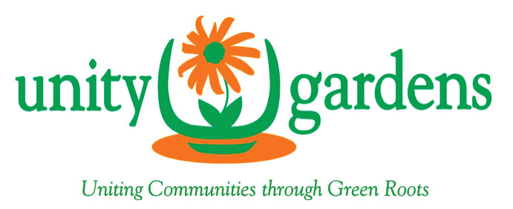
The mission of Unity Gardens is to empower local groups to build leadership and partnership through the creation of community greening projects that enhance the quality of life throughout
Anne Arundel County, Maryland

Home | About Us | Grants & Projects | Events | Get Involved! | Great Businesses! | Contact Us

Great Local Businesses!

Unity Gardens could not offer community greening grants and our popular annual speaker events without the gracious support of individuals and local businesses. Please return the favor by visiting the generous businesses below, and tell them Unity Gardens sent you! To learn more about how to support Unity Gardens, including becoming a donor or sponsor, or suggesting a local business who may be interested in supporting us, please visit our Get Involved page. Thanks to you, and all of our amazing sponsor & partners!

Sponsors & Partners Who Supported Our 2017 Annual Speaker Fundraising Event (links to Sponsors List in Great Businesses folder)

(Please add in logos below from the Logos file in the Great Businesses folder)

